Hello wonderful future assignment people, I thought I’d make this to help organize my the project and ultimately help me keep track of how much work I’m putting into this and where I need to work on next.

2022-10-23 13:36
Just added a way to close the window using functions + the close button. X11 is deinately an archaic display server with wayyyy to many ways to close. Hopefully the solution I’ve found works for most users. Does for me.
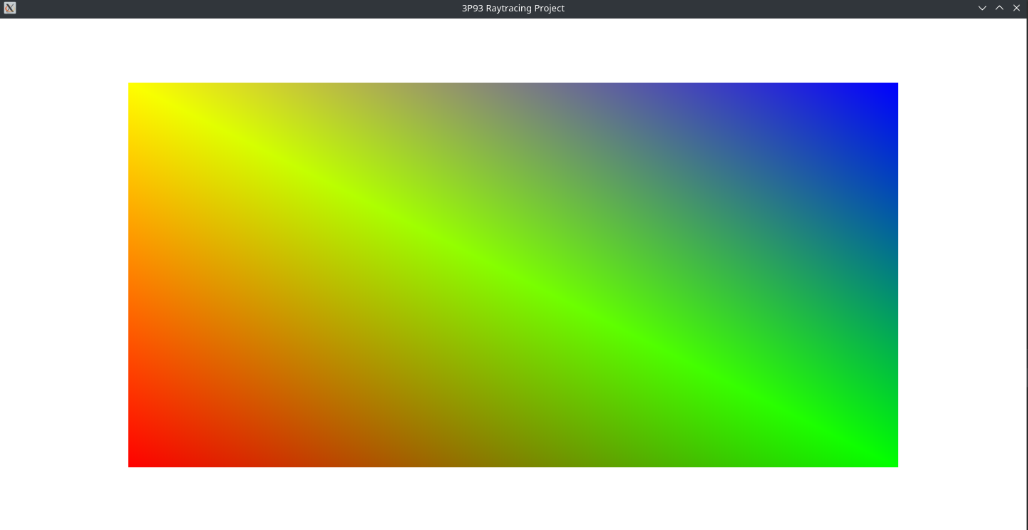
Next step is getting input working.

2022-10-23 14:07
Realized that it would be better to get at least something drawing on the screen before I try to do any input nonsense. Might be a bad idea but I need to get this done. So since the threads (single and multi) are only going to be writing to the image we can very easily just read data from the main thread without any worry. Even if the data is out of sync on the cache it’ll be up to date hopefully by the time we repaint the screen, which should be every 16.6666ms or 60 frames per second.
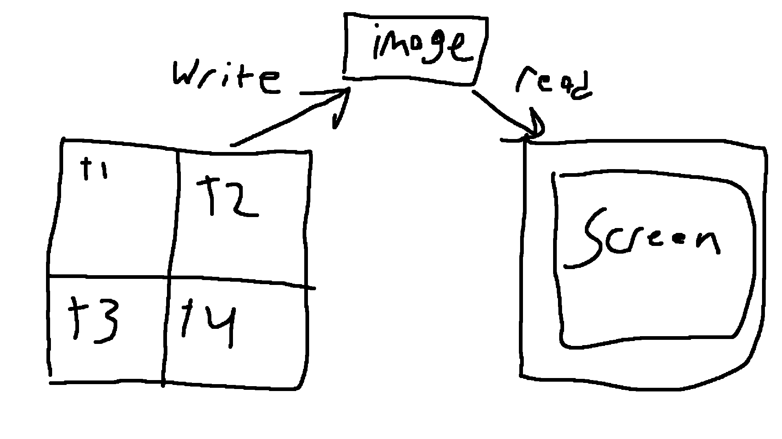

The general concept crudely drawn above.

2022-10-23 16:35
Multithreading is in although I was going to leave it for later. Currently running a debug session trying to determine where the segfault on larger images is occuring. Might have to move some stuff off the stack?

2022-10-24 17:27
Alright so I fixed multithreading so that every core is used 100% until the entire scene is finished. Did this by further splitting up the screen, adding to a queue, then each thread takes from that queue. Hardest part was trying to get the mutex to work and get the queue to not crash. Switched away from sending lambda functions and instead just send the numbered needed to do the rendering. However the queue did need to be made a heap object and not passed via reference. No clue why the reference to a stack object was giving such troubble but hey it works now and according to the profiler all threads are used about equally. Only takes about 20,955ms to render the same image that took 3.5 minutes on single threaded! Currently there is an issue with the renderer where the righr edge is a black bar and so I am going to go fix that instead of studdying for my midterms this week :/

Yes I was mulling over this all day today and yesterday :(

2022-10-24 17:32
Okay turns out this:
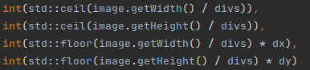

Was a really bad idea.
This fixes all black bar issues:
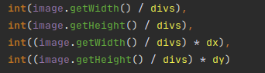

Let’s see if I can get some basic GPU stuff by the end of tonight.

2022-10-24 22:28
So I fixed the issues with really weird segfaults where the engine was writing to image pixels outside the with and height
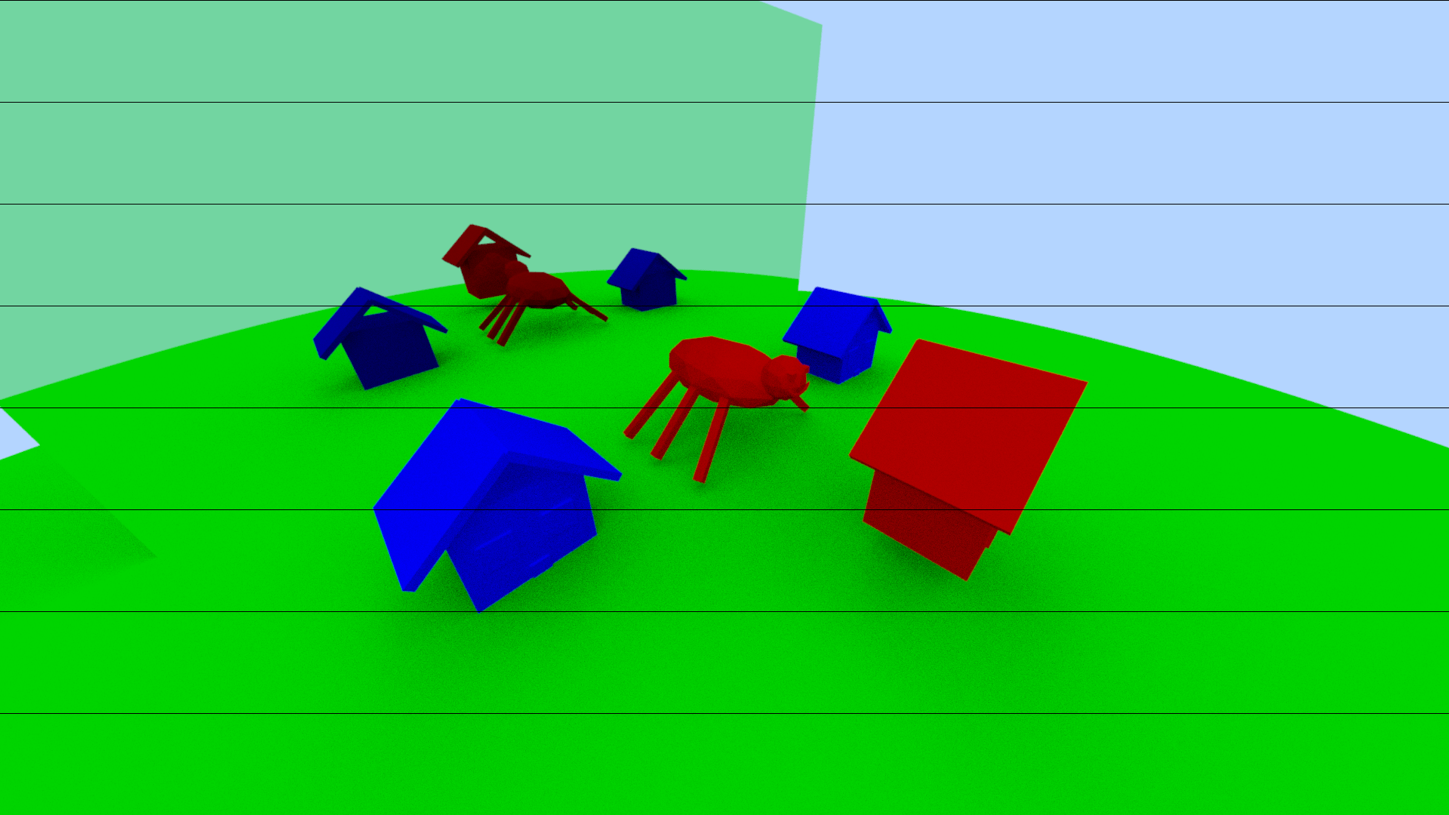
Except it causes this really weird issue which doesn’t make sense
So I think im just going to double the memory allocation or something. It’s small compared to whatever.

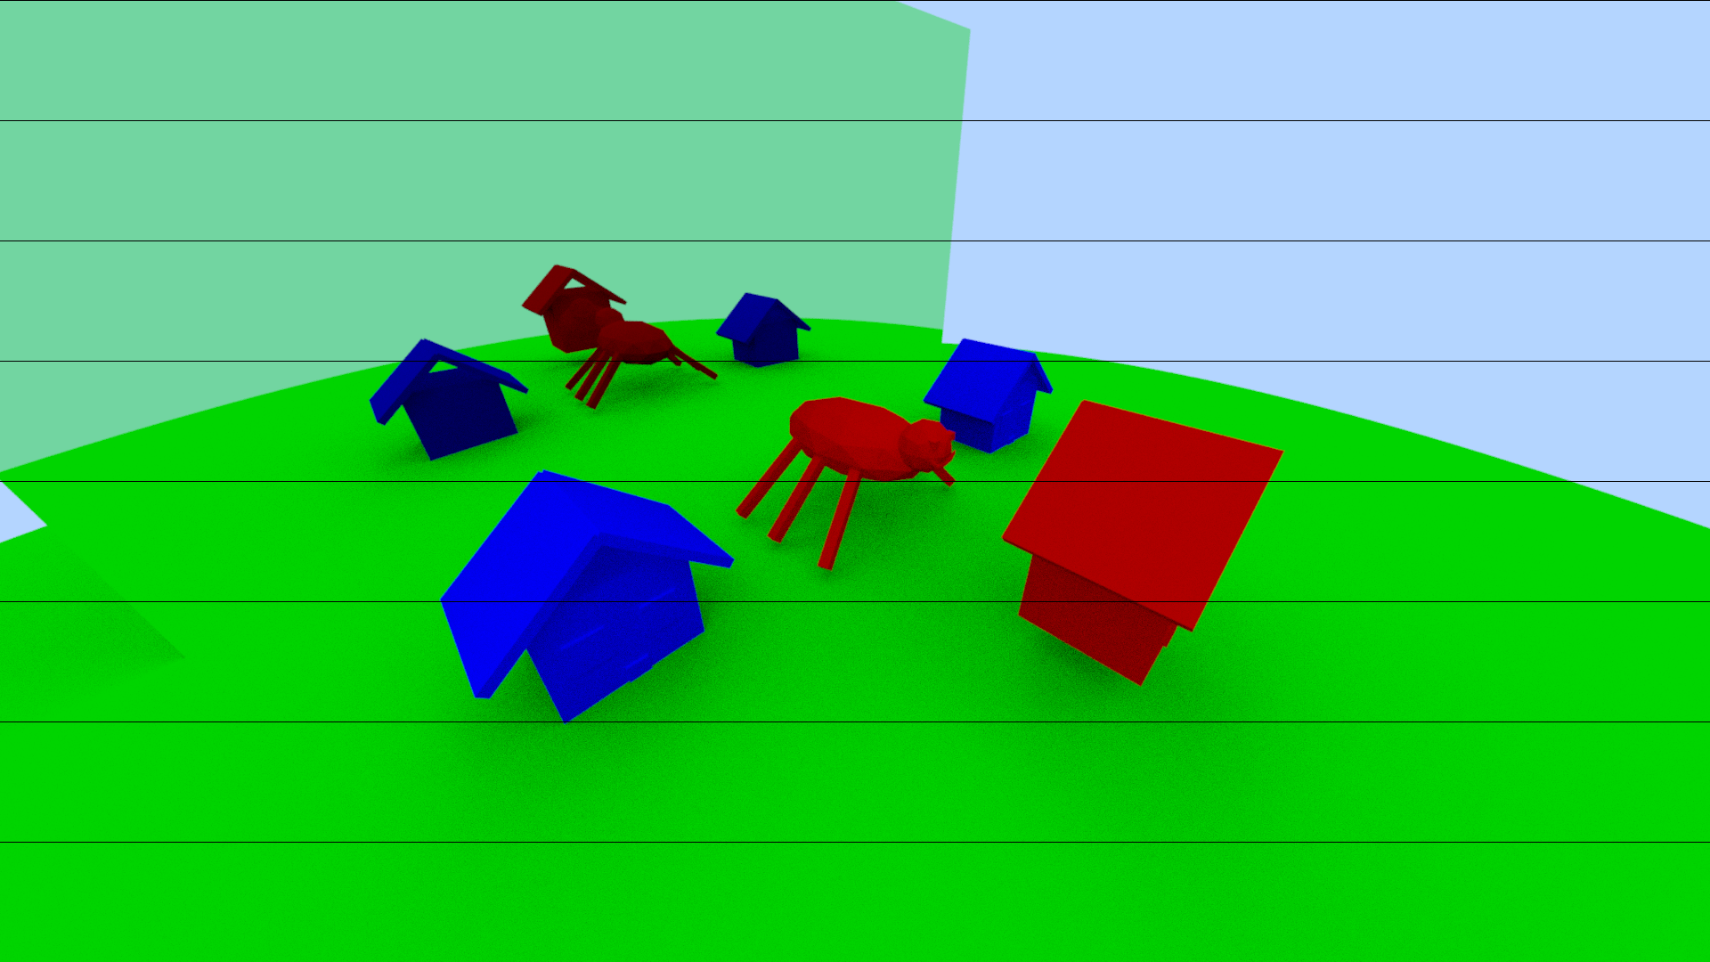
Didn’t fix much. Wonder what’s going on. Zooming in I can see it looks to be a floor issue rather than a ceiling issue. Might be realted to the offset causing the memory issues?

2022-10-25 00:09
Fixed the lines issue. No clue how. Well i think i changed a double to an int and now it works except that some resolutions have weird lines (1920x1080, default settings)
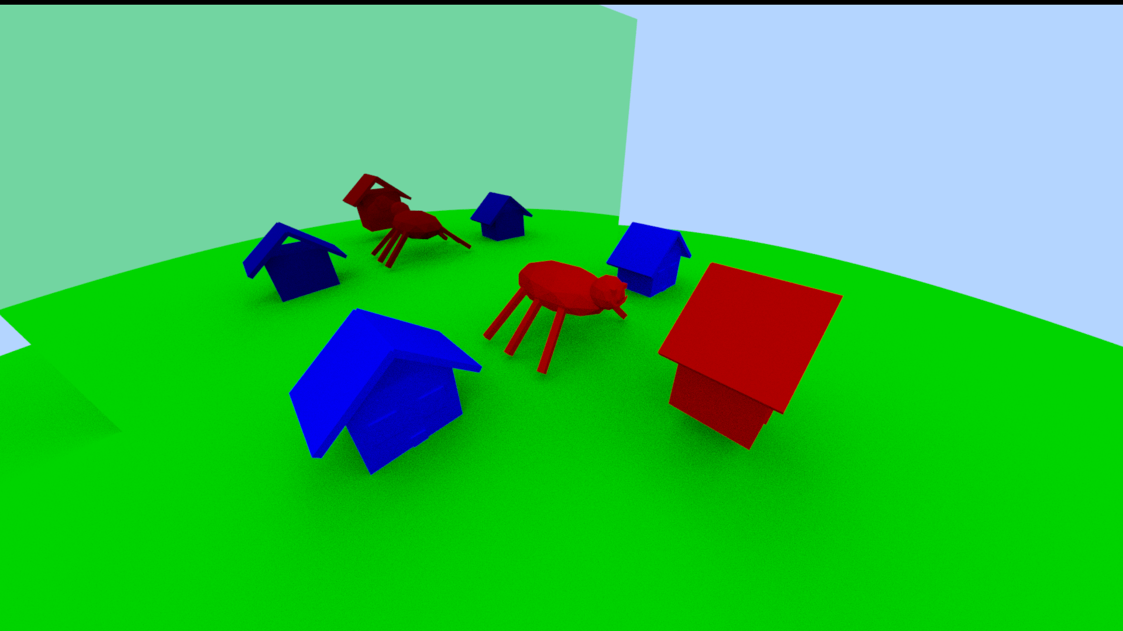
while others dont (2048x1024, 1440x720)
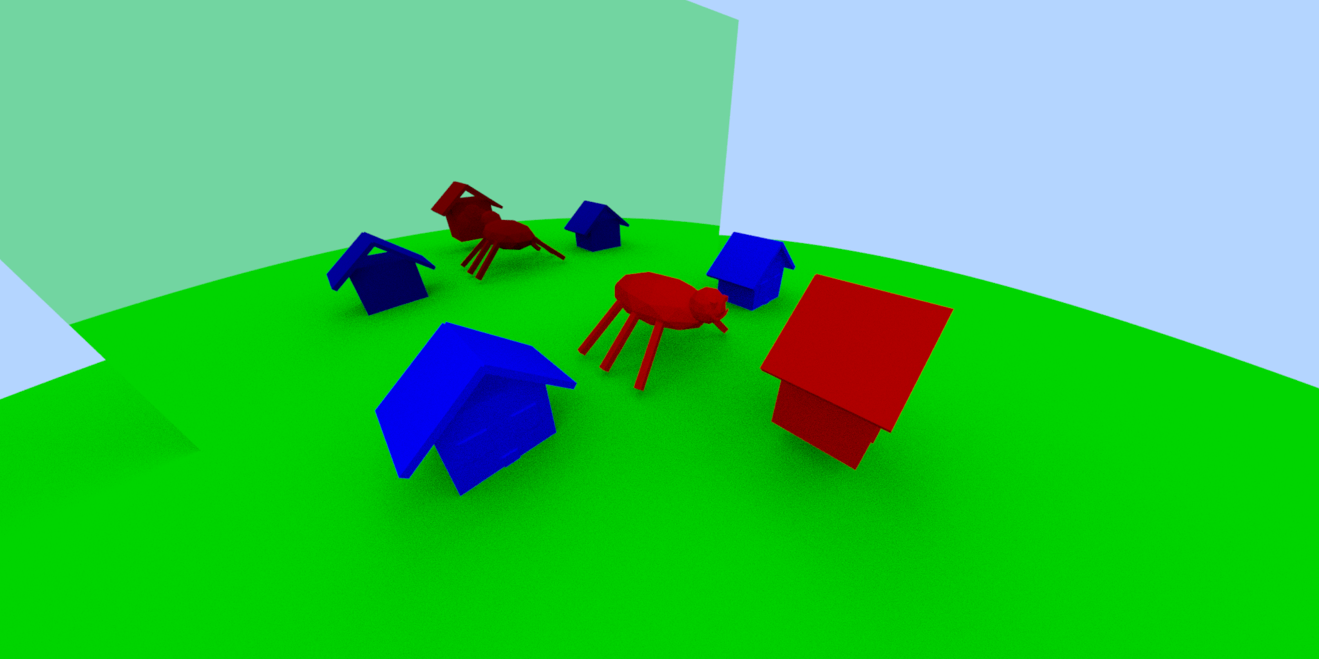
2022-10-25 01:04
Profiler says iterative version of the raycast function is 4.5% faster but im not sure if it’s accurate considering I’m taking a few shortcuts. Image looks fine though.

